Q1. [10+10 pts]
(a) Write a recurrence to describe the running time T(n) of the following function. Solve the recurrence and given a big Oh bound on the running time.

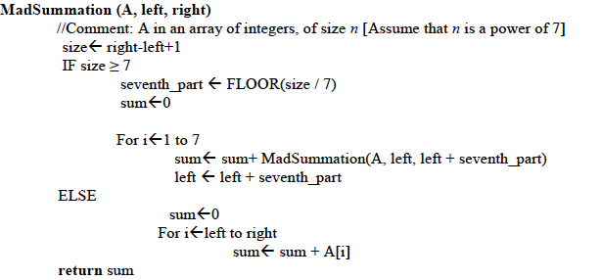
(b) Recall that the Partition (A, p, r) procedure of quick sort returns an index q such that each element of the sub-array A[p… q-1] is less than or equal to A[q] and each element of A[q+1… r] is greater than A[q]. Modify the partition procedure such that it produces two indices q and t, where p<= q<= t<=r, such that

- all elements of A[q… t] are equal to A[q],
- each element of A[p…q-1] is less than A[q], and
- each element of A[t+1…r] is greater than A[q].

First give a brief explanation of your method in English, then give C++ code.

For an n sized array, A, the running time of your method should be O(n).

Also note that p are r are the starting and ending indices of the array.

You cannot call any ready-made function inside your function.

Q2. [5+10+5] The Catalan numbers are defined as follows:
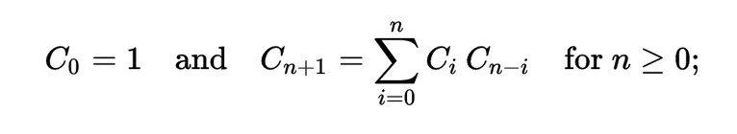
The 0th Catalan number is 1, and the rest are obtained by the recursive formula given above.

- Write a top-down recursive C++ function to compute the nth Catalan number.
- Write a bottom-up Dynamic Programming C++ function to compute the nth Catalan number. This function should also allocate the necessary memory required to store sub-problems.
- What are the running times in terms of big-Oh of the functions in (a) and (b)

Q3. [6*4] Answer the following questions briefly and top the point, do not write long notes.
- Name one feature of quick sort which makes it faster than merge sort in practice. Explain, in at most two lines, why it does so.
- If $f\left(n\right)=n^{1/2}$ and $g\left(n\right)=n^{2/3}$, then which of the following statements is true:
- $f\left(n\right)=O(g\left(n\right))$ (ii) $f\left(n\right)=Ω(g\left(n\right))$ (iii) both (i) and (ii)
- Suppose Dijkstra’s algorithm is run on the following graph. Show the final shortest path tree (take A as the source).

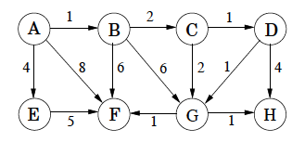
- The graph in (c) is also a DAG (directed acyclic graph). Show a linearization of this graph after performing topological sort.
- You pay someone k rupees today, and then every day till the end of their life they will keep paying you back half the amount of previous day starting with k/2. (So they will pay you k/2, k/4,…). How many days will it take them to pay back k rupees?
- A positive integer is called a perfect number if it is equal to the sum of all of its positive divisors, excluding itself. For example, 6 is the first perfect number, because 6 = 1+2+3. The next is 28 = 14+7+4+2+1. Write a program to find if a number is a perfect numbers. IsPerfect(int num){}

Q4. [5+5+5] Assume you are working in a software house and you are given a new project to work on. Following are the tasks to be done with their duration and dependency.

Activity | Name | Duration (days) | Depends on
A | Account framework | 6
B | Admin login | 4
C | User login | 3 | A
D | Add course | 4 | B
E | Remove course | 3 | B
F | System configuration | 10
G | Logout | 3 | E,F
H | View course | 2 | C,D

Starting date of project is 14th Dec. Answer the following questions. Your solution should be optimal.

- Suppose you want to find the earliest possible project end date. Given what we have studied in class, how will you model this problem? Show it.
- How will you find the project end date? Explain.
- Run your algorithm for part (b), show each step in a table.

Note: Rather than re-inventing your algorithm, reuse or transform the algorithms we have studied in class wherever possible.

